**5 Oct 2018** **The Weekly Bulletin of Rotary Club of Kathmandu Mid-Town** **bc-5.10/018**

|  |
| --- |
| C:\Users\Public\Documents\RIP T1819_EN.png |

District: 3292 Web:www.rotarymidtown.org.np Club Id: 26776

**OCTOBER IS ECONOMIC AND COMMUNITY DEVELOPMENT** **MONTH**

**Economic and community development is one of Rotary’s six areas of focus.**

Rotary clubs all over the world work with communities to enhance economic and community development Every community has different needs and different opportunities to serve.

Unemployment, underemployment, lack of economic opportunity, lack of appropriate training, and the absence of social safety nets lie at the core of poverty.

Creating productive employment opportunities is essential for reducing poverty and achieving sustainable economic and social development, and for providing income security and empowerment especially for women, people with disabilities, youth, and the extremely poor.

**Club Meeting # 1459** : 28 Sept 018

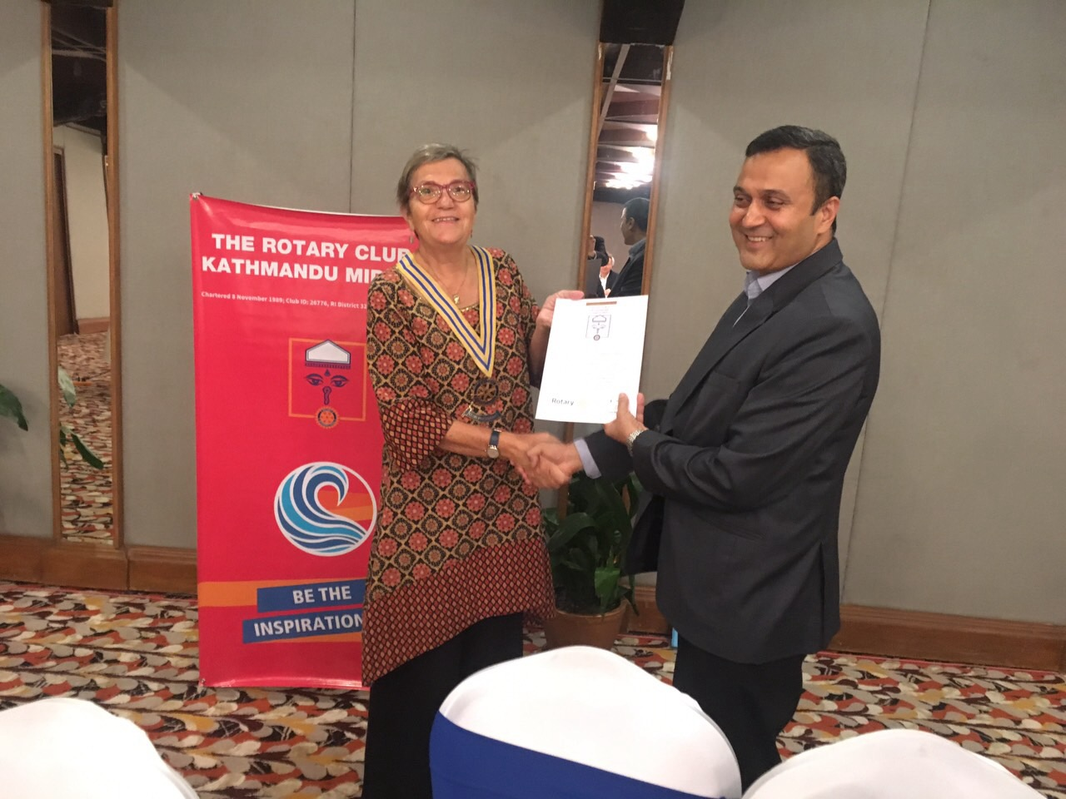

Guest speaker Janardan Dev Pant, CEO of Nirdhan Utthan Bank

Ltd, talked on micro credit in Nepal.

Nirdhan Utthan Bank Limited, “the bank for upliftment of the

poor” is a microfinance bank established in 1998.

NUBL follows group lending based on Grameen Bank,

Bangladesh model. The story behind the establishment of

“NIRDHAN” starts from 1986 when Late Dr. Harihar Dev Pant

visited Grameen Bank in Bangladesh. The visit inspired him

to launch microfinance program in Nepal resulting the birth

of “NIRDHAN” or “People Without Money” in 1991.

NIRDHAN began its microfinance operations in March 1993

President Jo handing over a certificate of appreciation to the guest speaker.

*Photo courtesy: Rtn Shyam R Thapalia*

# Weekly Meeting/Program Schedule:

|  |  |  |
| --- | --- | --- |
| Date | Program/ Speaker | Topic of Presentation |
| 5 October | Shilshila Acharya | Finding Sustainable Solutions in Nepal |

Friday Meeting: 5 Oct

Guest speaker: Shilshila Acharya, CEO of Himalayan Climate Initiative

Himalayan Climate Initiative (HCI) is a Youth driven Nepali Non-Profit Organization committed to Social Inclusion and Climate Resilience. It advocates Nepal to adopt a Zero-Carbon Economic Growth trajectory. HCI runs Social Innovation and Business Incubation Hub (SIBI Hub) in Kathmandu and Nepalgunj which has rolled out twelve socially minded start-up aligned to its three-pronged strategy.

Himalayan Climate Initiative (HCI) believes that for any non-profit organization to operate and succeed it must have significant support and trust of its stakeholders. HCI believes that in order for any organization to be a truly sustainable entity, it must be creating positive values in social, environmental and economic domains. HCI sets its goals and measures its impact using the triple bottom-line approach as accepted globally.

**CONGRATULATIONS:**

Our Club member Dr Ganesh Gurung has been appointed as a member of ‘Policy Research Academy’, a five-member ‘think tank’ recently formed by the government to suggest on various policy issues concerning economic, political, social and administrative reforms. **Congratulations!**

**Rotary project:**

In Cambodia, the Rotary Club of Phnom Penh is partnering with Rotary District 9800 (Australia) on an adopt-a-village project in Bosalla and Kroa Boa in Kampong Speu. The global grant project has been designed as a response to community assessment that showed 800 community members starving and dying from cholera and typhoid fever due to lack of clean water, sanitation, food, medicine, and education. The project aims to expand Rotarians’ efforts by training teachers and providing school resources, providing safe water and sanitation hygiene education, initiating mushroom and pig farming, and starting a silk weaving venture, leading to economic sustainability.

*Source: Rotary.org/economic\_community\_development\_project\_strategies\_en.pdf*

**A THOUGHT FOR TODAY:**

**“Seven blunders of the world that lead to violence: wealth without work, pleasure without conscience, knowledge without character, commerce without morality, science without humanity, worship without sacrifice, politics without principle.” -**Mahatma Gandhi

*Courtsey: Dr Isabella Khadka*

**Committee Chairs’ Column:** *(This column is for use by chairpersons of 5 permanent committees: Club Administration, Membership, Public Relations, Service Projects, and the Rotary Foundation)*

**Members’ Corner:** *(This column is for Club members to express anything they would like in matter of Club activities, Club administration, Club issues or on Breakfast Chatter, or on anything else that would be of interest to fellow members.)*

PP Mani D Joshi: reminds all concerned that once any part of the project is complete, the project-incharge should keep a copy of project report including photographs in record; this will greatly ease in preparing year-end reportings.

**Do you know?**

Humans accidentally created a[protective bubble](https://link.springer.com/article/10.1007/s11214-017-0357-5) around Earth.

Decades of use of very low frequency (VLF) radio communications have resulted in an artificial cocoon that could help protect the planet from solar flares and radiation particles.

*The Irish Time*

On Lighter Side:

After a morning fishing, a Rotarian left for a District meeting in the afternoon and his wife decided to motor out into the lake, drop anchor and read her book.

A game warden pulls up alongside the woman in his boat. ‘Good morning, Ma'am, what are you doing?’ “Reading a book” she replies.

“You're in a restricted fishing area” he informs her.

“I'm sorry, officer, but I'm not fishing, I'm reading".

"Yes, but you have all the equipment. For all I know you could start at any moment. I'll have to take you in and write you up."

"If you do that, I'll have to charge you with sexual assault" says the woman.

“But I haven't even touched you," says the game warden.

"That's true, but you have all the equipment. For all I know you could start at any moment."

"Have a nice day ma'am" the warden said, and he left.

I want clubs to have leadership development programs for their members. Rotary’s new vision

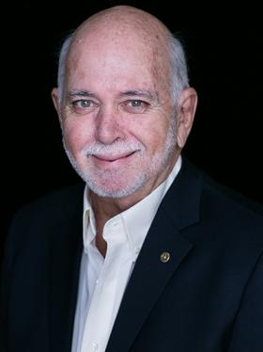

statement says: ‘Together, we see a world where people unite and take action to create lasting

change – across the globe, in our communities, and in ourselves.” It is a great opportunity to

remind everybody that as members of Rotary clubs, we’re also there for personal development.

Young people are looking for ways to grow and develop, and that gives them another reason to

join Rotary.

**RI President Barry Rassin**

Please send information on club activities, progress reviews on service projects, relevant photos etc to:

BC Editor: RR Shrestha email: rryesrr@gmail.com

## 5 Oct 2018 The Weekly Bulletin of Rotary Club of Kathmandu Mid-Town bc-5.10/018